# **User Guide**

# Monthly Expense

Check out the total monthly expense for each industry in your city!

Select expense type, and specify a data range and a plot will be generated automatically

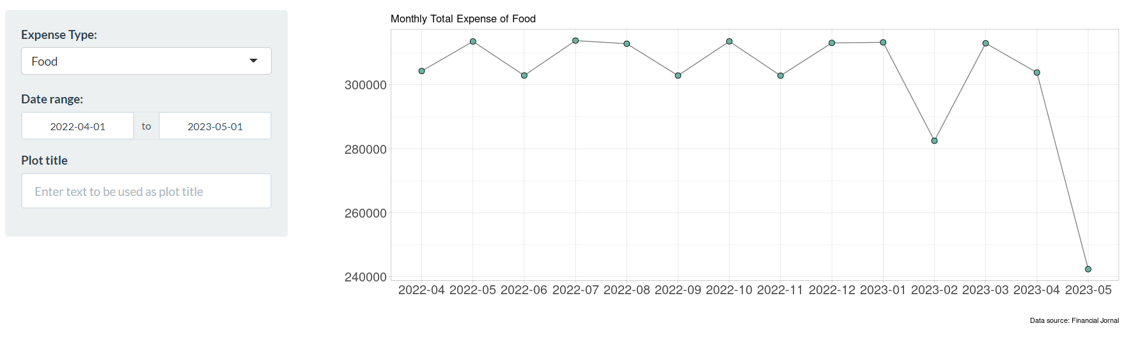

Figure 1. The interactable chart of Monthly Expense

# Food Industry

The right shows the plot of people’s monthly salary and the total time they spent dining out.

Specify a time range and the trend will be updated!

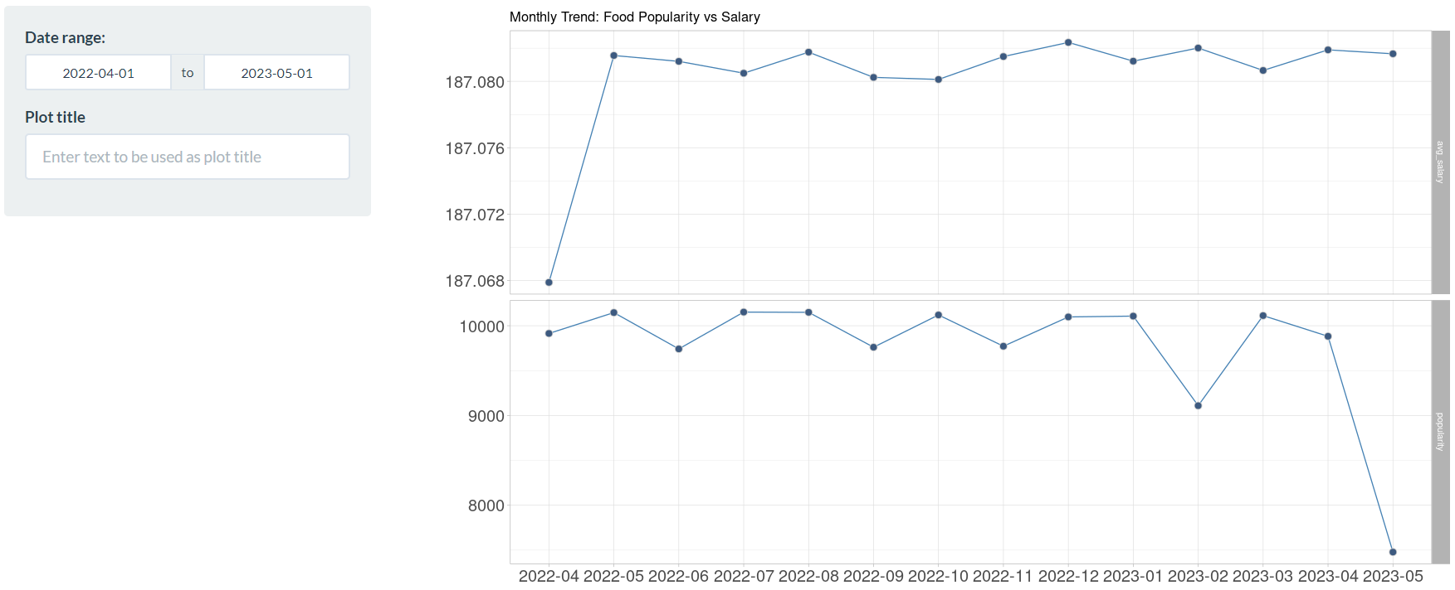

Figure 2. The interactable chart of Food Industry

# Engel Index

Engel index is widely used for analysing a place’s household wealthiness. You can find out participant’s Engel index by specifying the number of participants and a time range, and you can change to interactive mode to see the details by clicking **interactive** tab!

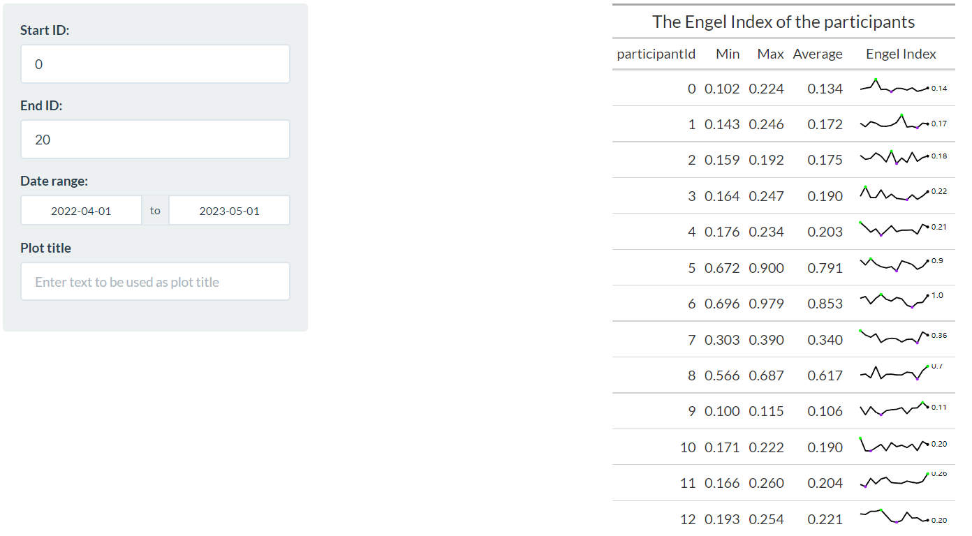

Figure 3. The interactable chart of Engel Index (Non-reactable)

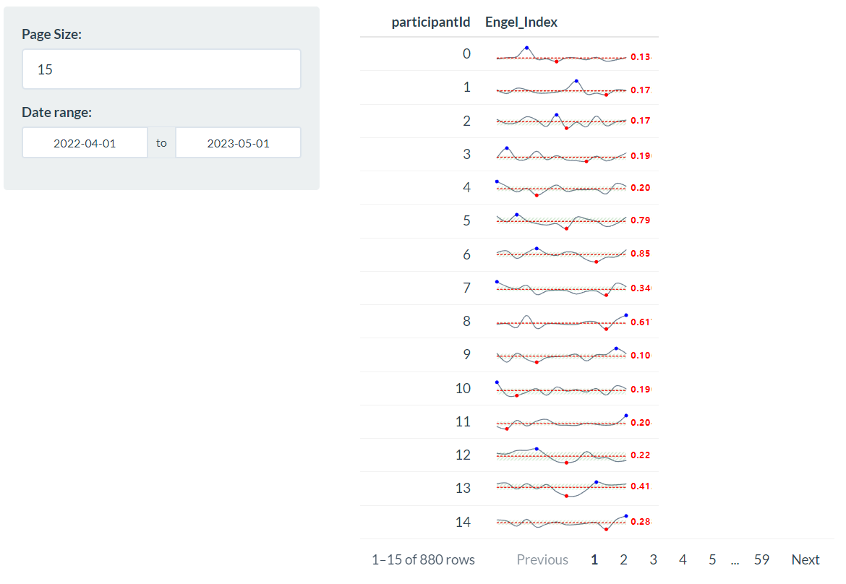

Figure 4. The interactable chart of Engel Index (Reactable)

# Living Expense

How will the spending patterns differ among different types of people? Find it out by selecting a demographical dimension and specifying a time range

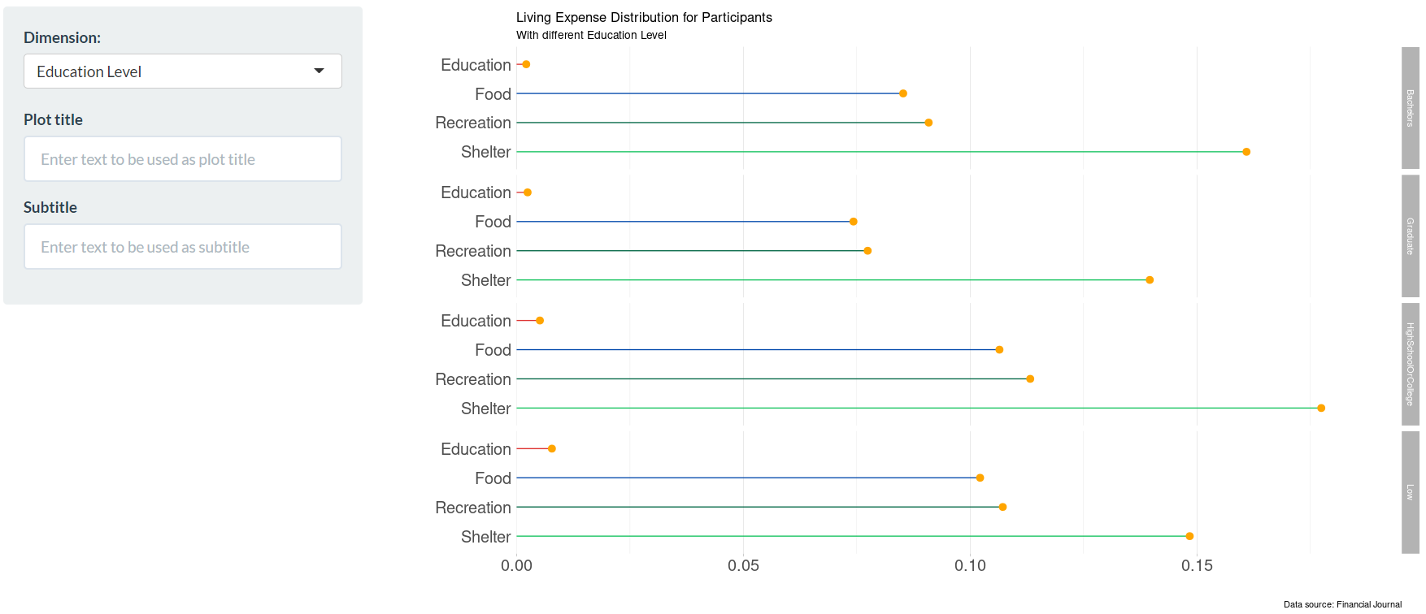

Figure 5. The interactable chart of Living Expense

# Savings

Will education level affect people’s saving patterns in your city? Find it out by selecting a subset of participants and specifying a time range

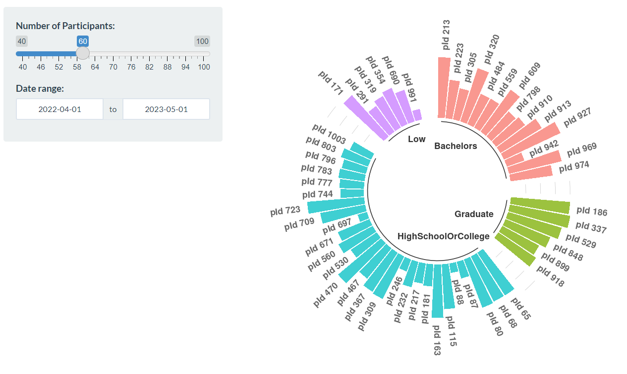

Figure 6. The interactable chart of Savings

# Employment

1. Understand the average wage of employees for each employer in a certain industry by choosing the industry name in the dropdown list.

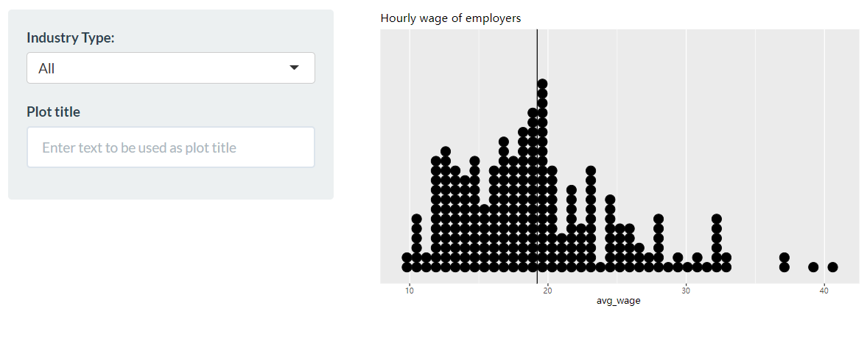

Figure 6. The interactable chart of Hourly Wage

1. Understand the average size of each employer in a certain industry by choosing the industry name in the dropdown list.

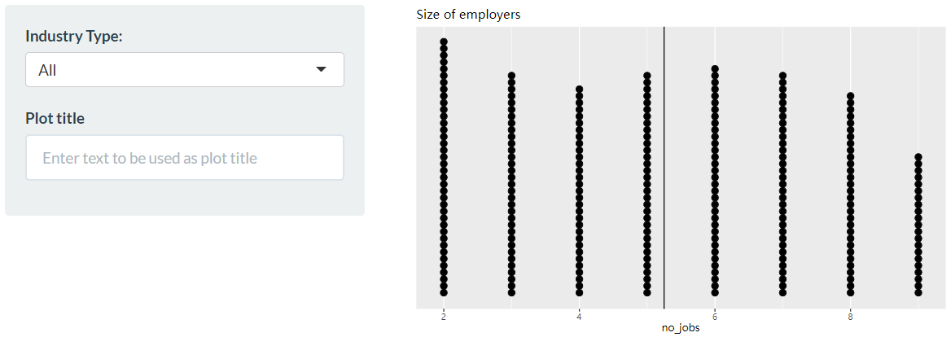

Figure 7. The interactable chart of Size of Employers

1. Shows the wage pattern for jobs with different education requirements.

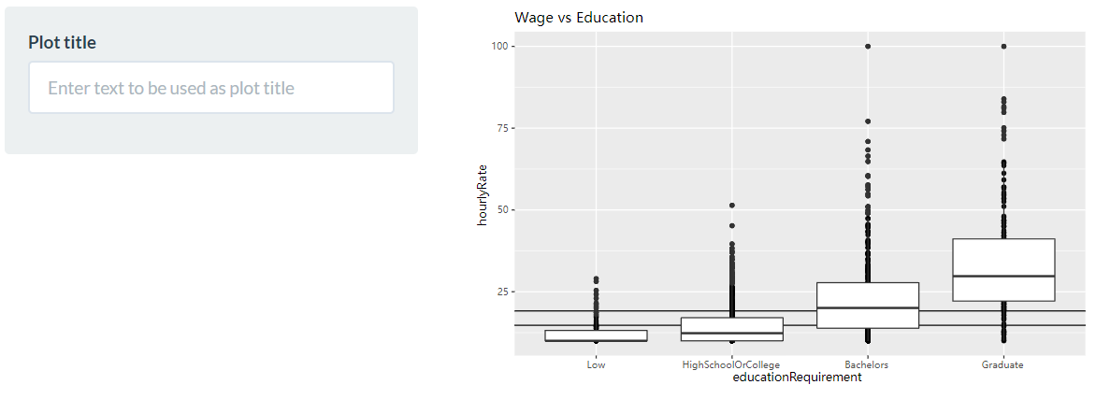

Figure 8. The interactable chart of Wage vs Education

# Regional Turnover

What is the busiest business district in your city? What is the most crowded residential area in your city? Find it out by specifying a building type and a time rage (in 24 hours).

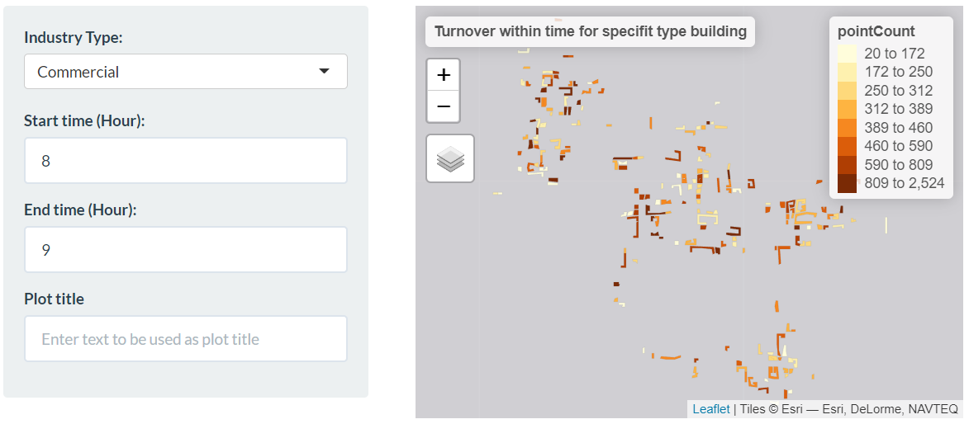

Figure 8. The interactable chart of Regional Turnover